**A review of Distributed Systems and Virtualization with examples of real-world programs.**

I will discuss the use of virtualization as it applies to Infrastructure as a Service (IaaS), Platforms as a Service (PaaS) and Storage as a Service (SaaS) or (SSP). These forms of virtualization share common underlying services. Where SaaS mainly focuses on providing storage solutions it can also provide infrastructure and platforms as well. The core idea is to provide clients a service, whether it be storage, applications, hardware access via remote access without the limitation of localized hardware system capabilities. These services together make up what is referred to as cloud computing. Virtualization in a local environment versus a remote cloud environment are different yet provide the same services. Virtualization on local hardware allows one server to run several individual computing environments. This same virtualization is utilized by cloud providers to divide physical servers into various computer environments and services that are provided to a client via the internet. There are many applications that provide clients with local hardware virtualization however I focused this discussion on services provided cloud computing.

Storage as a Service (SaaS) also referred to as Storage Service provider (SSP) is the use of virtualization to provide storage infrastructure to a business or individual. This service sounds like Software as a Service (SaaS) but for the purposes of this paper I will be focusing on SSP. SSP can be found bundled into many other forms of virtualization services such as IaaS and PaaS. The usefulness of this type of virtualization can be seen in remote backups. The user avoids paying an overhead for hardware, personnel to manage the storage and physical space. Accessing SaaS solutions can be done several ways. Individuals or smaller companies can use a provider’s API via desktop application or web-based content to transfer data to and from the remote storage site. (2) Some commonly used SaaS providers are Google Cloud Services, Microsoft Azure Storage and Amazon Web Services. Storage as a Service is sometimes referred to as “Cloud Storage”. (1)

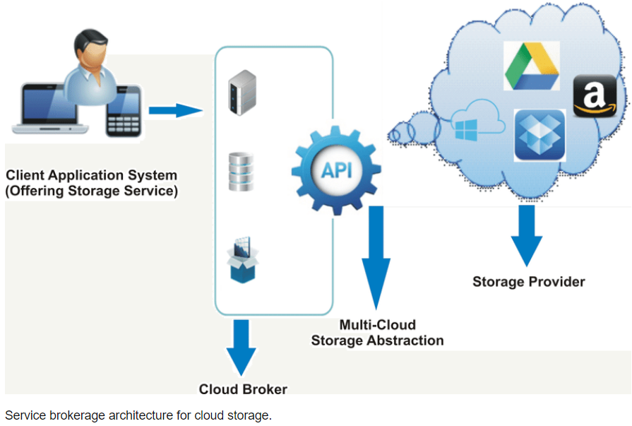

This form of virtualization of storage space provides clients with a way to restore during disaster recovery since the data can be restored to any location. SSP also provides clients with a reliable way to store data without the initial cost of setting up and deploying local storage solutions.

Platforms as a Service (PaaS) allows developers to build application and services over the internet. PaaS is hosted in the cloud and accessed via the client's web browser. This allows software to be built and tested on an array of environments offered by the provider. (4) This form of virtualization allows clients to only pay for the applications they intent to use without worrying about having specific hardware specifications to run the application. Development teams can focus on code and its deployment rather than the administration of systems, databases and middleware, security and runtime environments. Popular PaaS providers include Amazon Web Services Elastic Beanstalk which supports web apps development in Java, .Net, PHP, Ruby, Node.js and Python to name a few. A client can upload their code base and AWS Elastic Beanstalk will provide database integration, deployment provisioning and auto-scaling if needed. (5) Other popular providers include Google App Engine, Microsoft Azure and Salesforce APPAS.

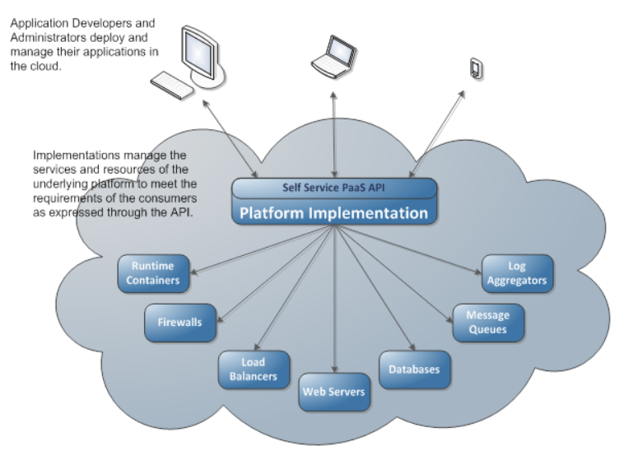

Infrastructure as a Service (IaaS) is a virtualized computing resource offered to clients via the internet. IaaS offers access to virtualized components for clients to develop their own individual IT platform on. (1) IaaS can pull resources from many servers and networks across numerous data centers. It is scalable and this gives clients a better reliability and financial savings since they can pay for only the amount of infrastructure needed to be operational. Common providers of IaaS include Microsoft Azure, Amazon AWS, Rackspace Open Cloud and IBM SmartCloud. Clients are given access to a virtual hardware system that they can install their desired operating systems and implement any software needed. Even network systems can be implemented to test applications and manage loads.

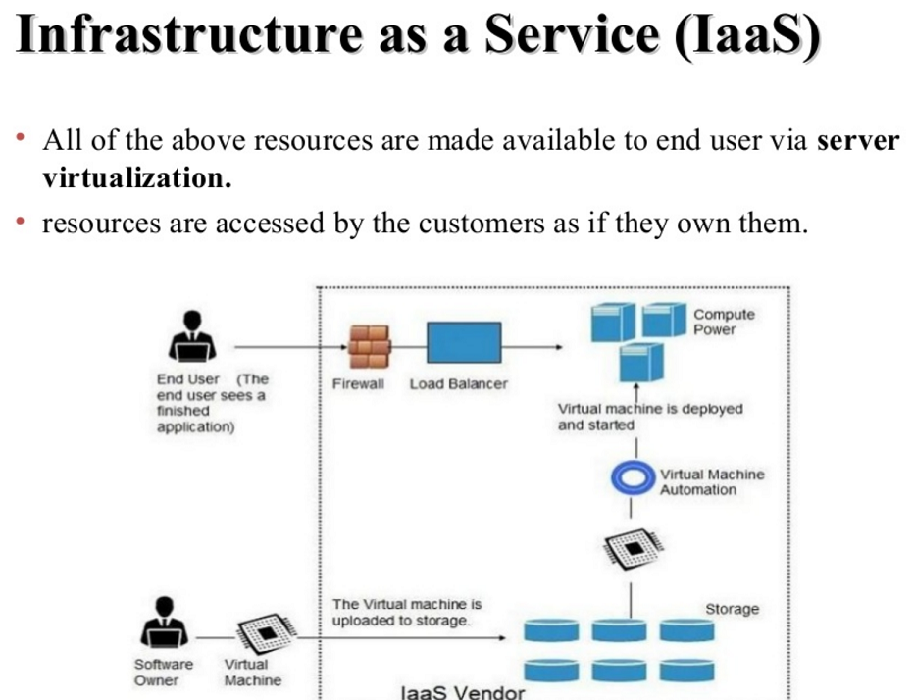

The differences between these infrastructures is blurred but can be narrowed down to the following: IaaS providers supplies basic computer, storage and networking infrastructure with a hypervisor. The client is responsible for creating and configuring the virtual machines, installing the operating systems, applications and data. PaaS providers build on IaaS and include the operating systems, middleware and various runtime environments to the client. SSP only provides the client with the ability to store data in a secure manner at a remote location via software application.

All these services are provided thanks to virtualization technologies. Virtualization at its core allows providers the flexibility to allow clients to utilize hardware resources distributed amongst many instances. Several servers at a local can run a multitude of virtualized machines, operating systems, software and networks separated by each client's needs. If a client needs more computing storage, then the provider can allocate more resources to that client. If a client needs a specific operating system to run a development environment on, then the provider can offer those services or allow the client to install the required elements. This flexibility allows individuals, small businesses and enterprises to reliably and cost effectively operate.

**References**

1. Volino, B. (2019, August 15). “What is IaaS? Your data center in the cloud” Retrieved from <https://www.infoworld.com/article/3220669/what-is-iaas-your-data-center-in-the-cloud.html>
2. Editor. (2018, July 27). “Here are 5 types of virtualization” Retrieved from <https://www.techadvisory.org/2018/07/here-are-5-types-of-virtualization/>
3. Techopedia. (unknown). “What is Storage as a Service” Retrieved from <https://www.techopedia.com/definition/24900/storage-as-a-service-saas>
4. DCTalk. (2017, June 24). “What is Platform as a Service (PaaS)?” Retrieved from <http://dctalk.com.bd/what-is-platform-as-a-service-paas/>
5. Davies, A. (unknown). “Top 10 PaaS providers for 2019” Retrieved from <https://www.devteam.space/blog/10-top-paas-providers-for-2019/>